PHYSICS QUESTIONS

Institution

Date of submission

1. Fields
An insulated wireframe which made of a rigid wire in the form of a right-angled triangle PQR has two beads of the same mass m which carry charges q1 and q2 and connected by a cord of some length L which can slide without friction on the wires on a vertical plane as shown below. If the beads are stationary, calculate,
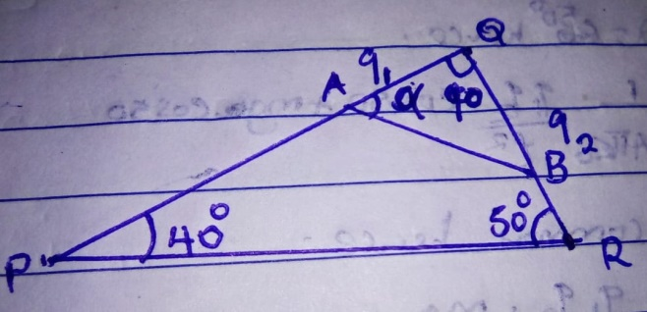
- The angle α (angle QAB)
- The tension of the cord
Solution
Steps
We have to analyze all the forces action go the beads and they are,
- Mg i.e. force due to gravity that works downwards
- Tension: there is a force of tension that occurs on the cord
- Electric force due to the presence of the charges q1 and q2.
- Normal reaction force as the beads lies at a vertical ground.
These forces can be shown better in the diagram below and the calculations hence follows.
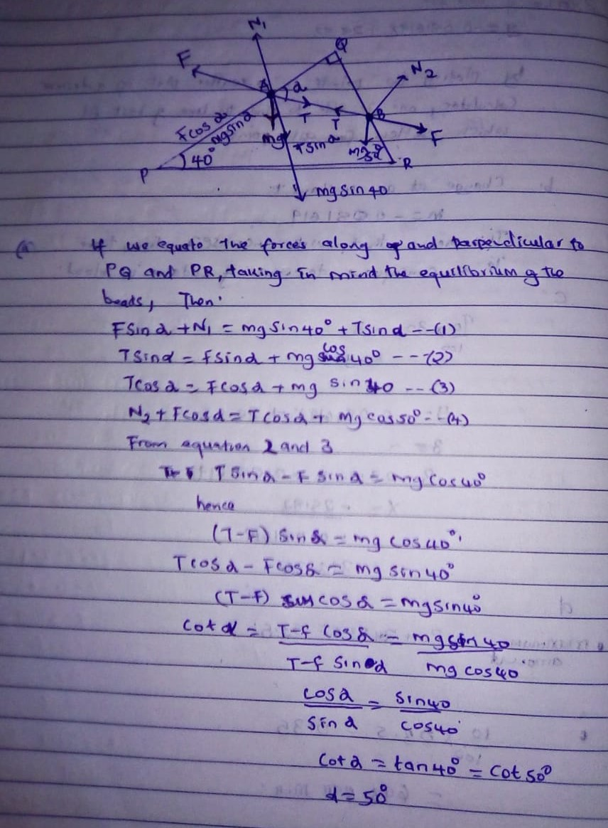

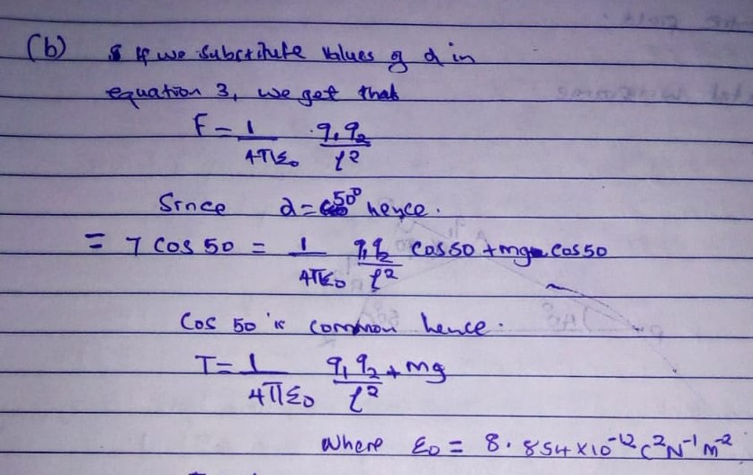
2. Energy And Momentum
A stone P with a mass of 2.5 kg is moving due north with an average velocity of 3m/s . Another stone R with a mass of 3.0 kg moves due north with a velocity of 2.0 m/s. Ball P overtakes ball R and collides from behind with it. After the collision, stone P then moves due north with a velocity of 1.5 m/s. What will be the velocity of stone R after collision?
Solution
Here, we have to consider the law of conservation of momentum and have the following equation cropping up.
pPbefore+ pRbefore=pPafter+pRafter
Since p= mv, we will have to substitute this to our equation above and get
mPvP+mRvR=mPv′P+mRv′R
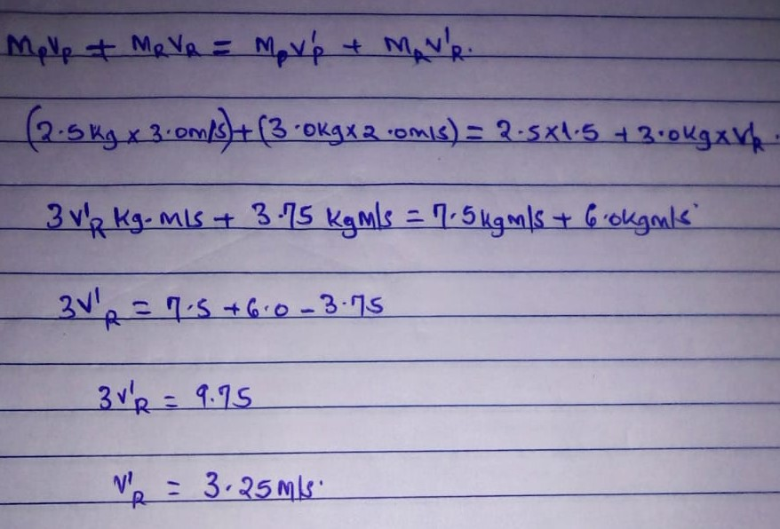
Hence, after collision, the stone R moves due west at a velocity of 3.25m/s

3. The Wave Nature the Light
Light whose wavelength is 700nm passes through a single slit of width 3.5*10⁻⁶m. A screen is places 2.1m away from the slit. What would be width of the central maximum in degrees and in meters?
solution
The width of the slit is a distance d and a screen is away at a length l from the slit. It is noted that, for a single slit, the middle has a bright fridge .we do not have any other bright fridges as the wave progresses along the screen. Hence in this case, m will be based on the dark fridges rather than bright fridges as shown in the figure below.
Hence, by calculations, the width will be,
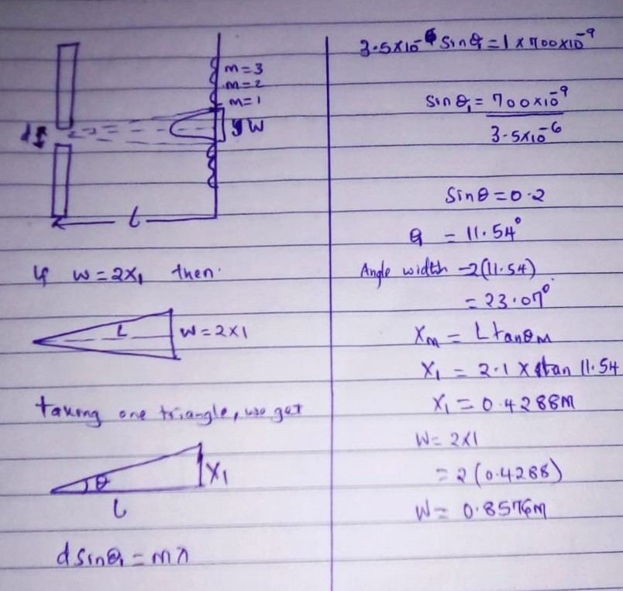
Hence the distance by angle of central maximum is 22.07⁰ and distance in meters is 0.8576m.

4. Dynamics Part 1 Lessons
Make g the subject of the formulae .
S=ut+$\frac{1}{2}$gt²
Solution
The equation above is an equation of linear motion under gravity. From this, we can note that the object moves towards the center of the earth as the gravitational constant is positive. This is called free fall motion
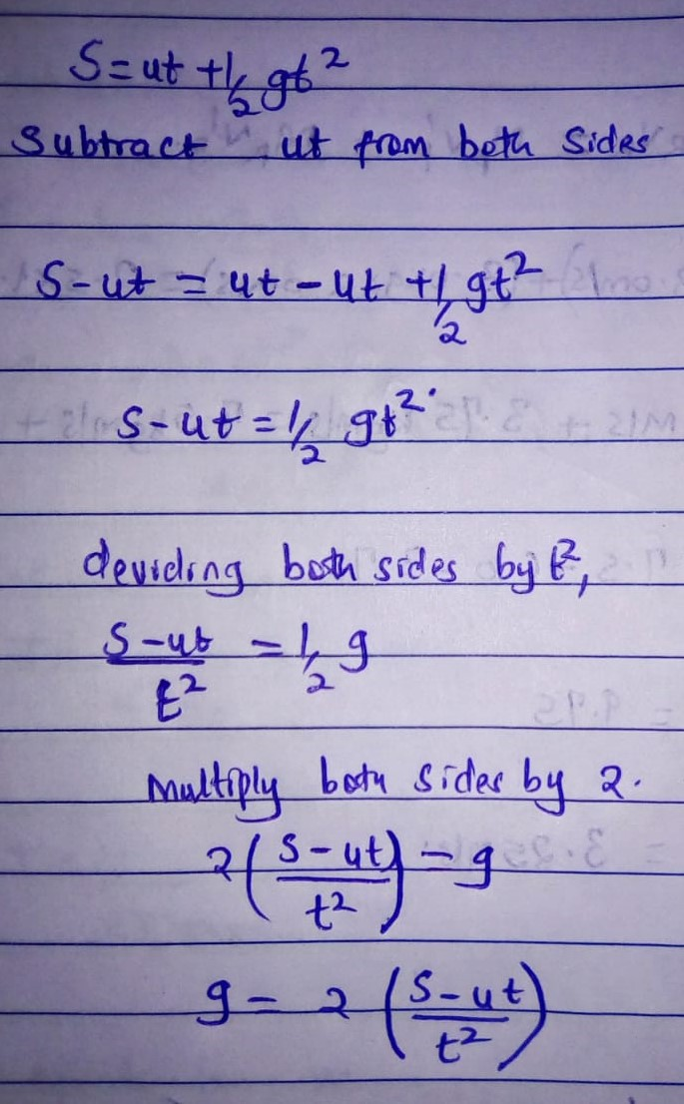
And hence g=2($\frac{s-ut}{t*t}$)
5. Dynamics Part 2 Lessons
An object of mas 30kg is accelerated on a frictionless surface from rest to 10m/s in 4 seconds. What will be the force acting on it?
Solution
When a body is accelerated on a frictionless surface, then this means that it obeys the newton’s second law of motion whose equation is f=ma
Therefore, solving this we get
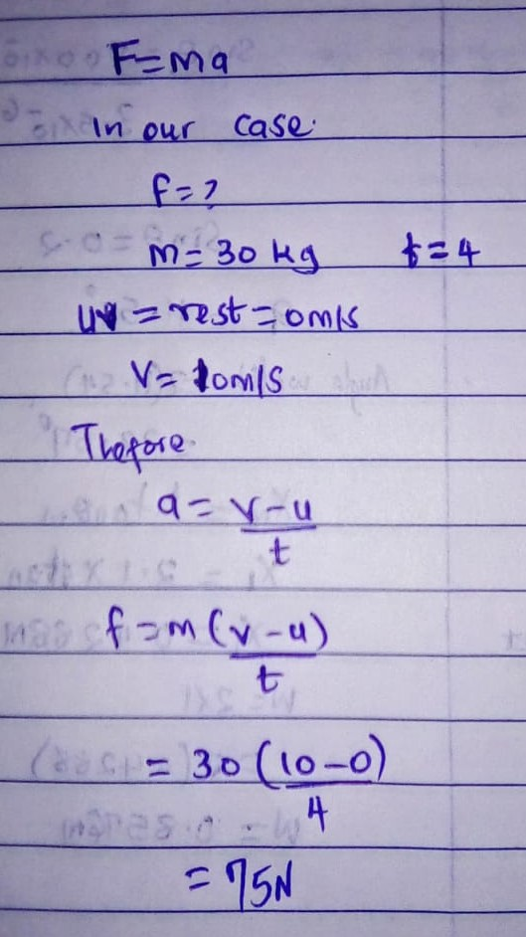
References
Question 1
Che, F., Gray, J. T., Ha, S., Kruse, N., Scott, S. L., & McEwen, J. S. (2018). Elucidating the roles of electric fields in catalysis: A perspective. ACS Catalysis, 8(6), 5153-5174.
Shaik, S., Danovich, D., Joy, J., Wang, Z., & Stuyver, T. (2020). Electric-field mediated chemistry: uncovering and exploiting the potential of (oriented) electric fields to exert chemical catalysis and reaction control. Journal of the American Chemical Society, 142(29), 12551-12562.
Question 2
Sedaghatnia, P., Hassanabadi, H., & Ahmed, F. (2019). Dirac fermions in Som–Raychaudhuri space-time with scalar and vector potential and the energy momentum distributions. The European Physical Journal C, 79(6), 1-8.
Yu, L., Zeng, Y., & Su, Z. (2020). Understanding the mass, momentum, and energy transfer in the frozen soil with three levels of model complexities. Hydrology and earth system sciences, 24(10), 4813-4830.
Question 3
Wu, E. T. (2020). Single Slit Diffraction and Double Slit Interference Interpreted by Yangton and Yington Theory. IOSR Journal of Applied Physics (IOSR-JAP), 12(2).
Teng, B., Teng, P., & Hennekens, C. H. (2018). A simple way to teach single slit diffraction based on edge diffraction. The Physics Teacher, 56(6), 380-383.
Question 4
Zhang, Y. (2017). Variational problem of Herglotz type for Birkhoffian system and its Noether’s theorems. Acta Mechanica, 228(4), 1481-1492.
Fey, J. T. (2018). School algebra for the year 2000. In Research issues in the learning and teaching of algebra (pp. 199-213). Routledge.
Question 5
Erfan, M., & Ratu, T. (2018). Analysis of Student Difficulties in Understanding The Concept of Newton’s Law of Motion. JIPF (Jurnal Ilmu Pendidikan Fisika), 3(1), 1-4
Pili, U. B. (2020). Expressing Newton’s second law of motion as Fnet= 2ma and kinetic energy as KE= mv 2. Physics Education, 55(5), 053003.

